Forecasting Of Flood Levels in a River
Dr. Vijaya Kumar AV(Professor)
Computer Science & Engineering
Presidency University
Bengaluru, India
Karnatakam Manohith
Computer Science & Engineering
Presidency University
Bengaluru, India
karnatakam.20221cse0199@presidencyuniversity.in
Vaddireddy Sivananda Reddy
Computer Science & Engineering
Presidency University
Bengaluru, India
Vaddireddy.20221cse0245@presidencyuniversity.in
Palem Sreedhar Rao
Computer Science & Engineering
Presidency University
Bengaluru, India
Palem.20221cse0221@presidencyuniversity.in

Abstract
River flood is still one of the most devastating hazards for human societies, particularly in areas with extensive and high populated flood plains. Besides immediate effects such as damage to infrastructure and loss of crops, flooding events trigger a cascade of secondary socio-economic and ecological consequences, which in some cases persist for years. Current approaches to address flooding emphasise stage predictions (i.e. river height), rather than providing accurate spatially referenced information on flood extent. This leads to a lag between data availability and the usefulness of decisions that can be made.
In this paper, a real-time IoT-based measurement and monitoring process is developed using high quality sensors combined with AGISFLO WEPPA hydrodynamic modelling to address this gap in knowledge. Through building an integrated stack from bottom to top in order for on-the-ground sensors, cloud-based analytics and user-friendly visualization interfaces work together, the framework can turn raw hydrological forecasts into a sensible map/ alert that triggers action. In addition, the system is made to be robust with hybrid communication schemes and solar autonomy enabling it to work even in catastrophic conditions.
Index Terms—Flood Inundation Mapping, IOT Sensors, Hydrodynamic Modelling, GIS
Disaster Management Early Warning System Real-time Monitoring HEC-RAS.
I. INTRODUCTION
1.1 Inspiration along with background
Floods are becoming more frequent and severe, driven by climate change as well as greater urbanization and human interference in river systems Countries including India and Bangladesh, as well as swaths of sub-Saharan Africa, have weathered catastrophic floods in the last two decades that have uprooted millions.
The Intergovernmental Panel on Climate Change (IPCC) estimate that probability of flooding will rise by 30% in the most at-risk areas globally by 2050.
Warned as we are today, we have no very particular prediction in most of our settlements about whose homes will be tortured by flood waters. For instance, a local government may have information indicating that the Yamuna or Ganga river will rise by 2.5 meters, but in the absence of knowing which villages and roads will actually be impacted, they cannot plan for safe evacuations or resource management effectively.

1.2 Project Statement
If we are talking about predicting where water will flow, then the answer is: Not beyond very short ranges of time and space, said Paul Doss of the Consortium of Universities for the Advancement of Hydrologic Science. At present, Meterological department is predicting the water related situations like amount of rainfall, area covered by the river. Generally, that does not predict the correct water related problems. Especially, they don’t provide the exact location where the problem can occur.
Disaster Management needs another information like which the roads are draining ,which schools are draining, which farming lands are affecting , who will reach them as faster as possible. Climate changes does not provide all this information and cannot be utilized properly.
1.3 Project Objectives
The objectives of the project are both physical and digital:
• Build Eco-friendly IoT sensor systems to measure the weather and water conditions.
• Leverage an Edge Computing capable of real-time notifications to any place.
• Develop prognostic models of water flows to form strong connection with the IoT data.
• Combine high-resolution elevation maps with water flow models to effectively determine impacts on land areas.
• Develop basic web and mobile apps for use by law enforcement and the general public.
• Employ continuous systems to modify and reduce the error of predictive warnings

II. Review with Technical Analysis
2.1 REVIEW
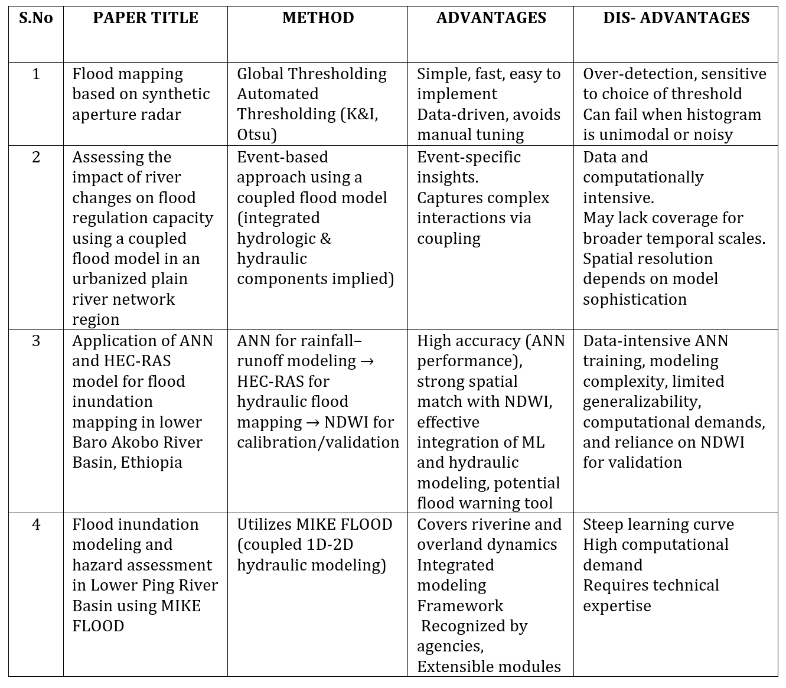

2.2 Research
• On the hydrologic models: Today’s models were designed based on bygone methods that viewed precipitation and runoff in isolation—which makes them largely obsolete. Present-day models tend to use the hydrodynamic solvers as HEC-RAS more frequently as it enhances channel flow simulation.
• IoT adoption: Then ,the data of the river was measured manually. Today, based on IoT networks, monitoring water levels and flow far away with the accuracy of density measurement is feasible.
• Visualization leap: Prior models created static maps, which were typically included in scientific papers and hard for people to find. Today, Web-GIS dashboards are creating accessible information about these vulnerabilities to be understood by ordinary citizens without expert knowledge.
This is where this work contributes with and utilizes these developments, by merging machine learning to IoT and GIS technologies, aimed at enabling the provision of real time useful information on flood risk.

III. Architecture of the system with methods
3.1 Architecture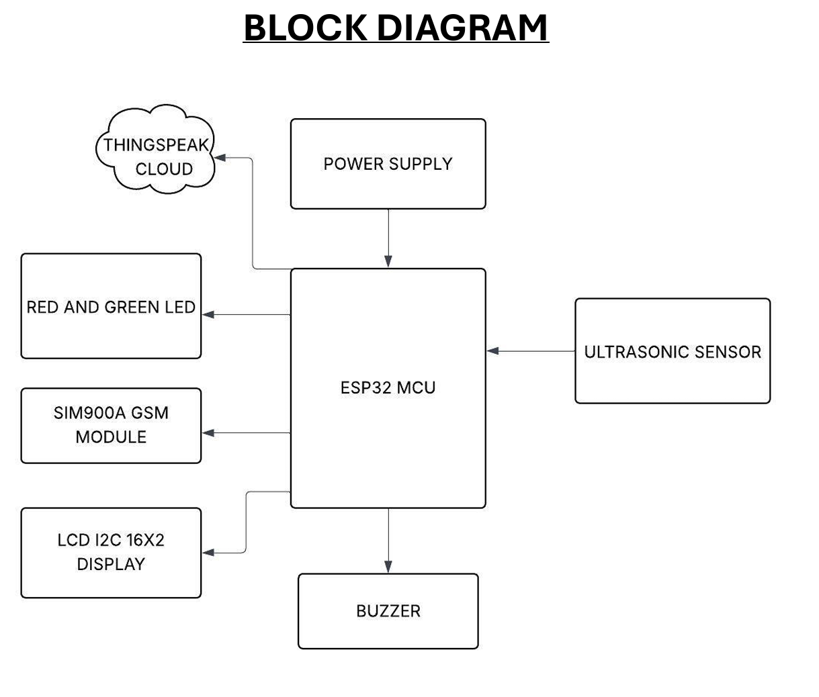
Figure 1
The architecture is a fault-tolerant pipeline of layers. Fig. 2 displays the data pipeline occur from IoT field sensors → edge processing unit or cloud aggregation server → hydrodynamic simulation model or/and GIS visualization platform. Unlike 'stand alone' models, this model can accept feedback (eg the model calibrates with observed results).
Advantages:
• Edge devices cut down on the data that needs to be transmitted by processing information before it is sent.
• Hybrid communication formats that keep data secure and available, even with a connection issue.
• The simulated outputs are converted to GIS layers, and can be visualized easily and directly with widely used mapping software.

3.2 Data Acquisition Layer (Detail)
The field hardware is still the key to prediction accuracy.
• Water level sensors: Pressure transducer-based is less influenced by sediment and water movement, whereas ultrasonic-and radar-based ones experience less wear through physical contact. Both types are used in combination effectively to enable an accurate measurement even in the case that the river condition fluctuates.
• Rain gauges: which use an electronic tipping bucket for accuracy and can time stamp all measurements to obtain accurate rainfall data.
•Power play: During extended rainfall events, solar panels are connected to regulators designed to conserve power and ensure uninterrupted flow of water.

3.3 Data Processing and Merging with Model Outcomes(Detailed Methodology Extension)
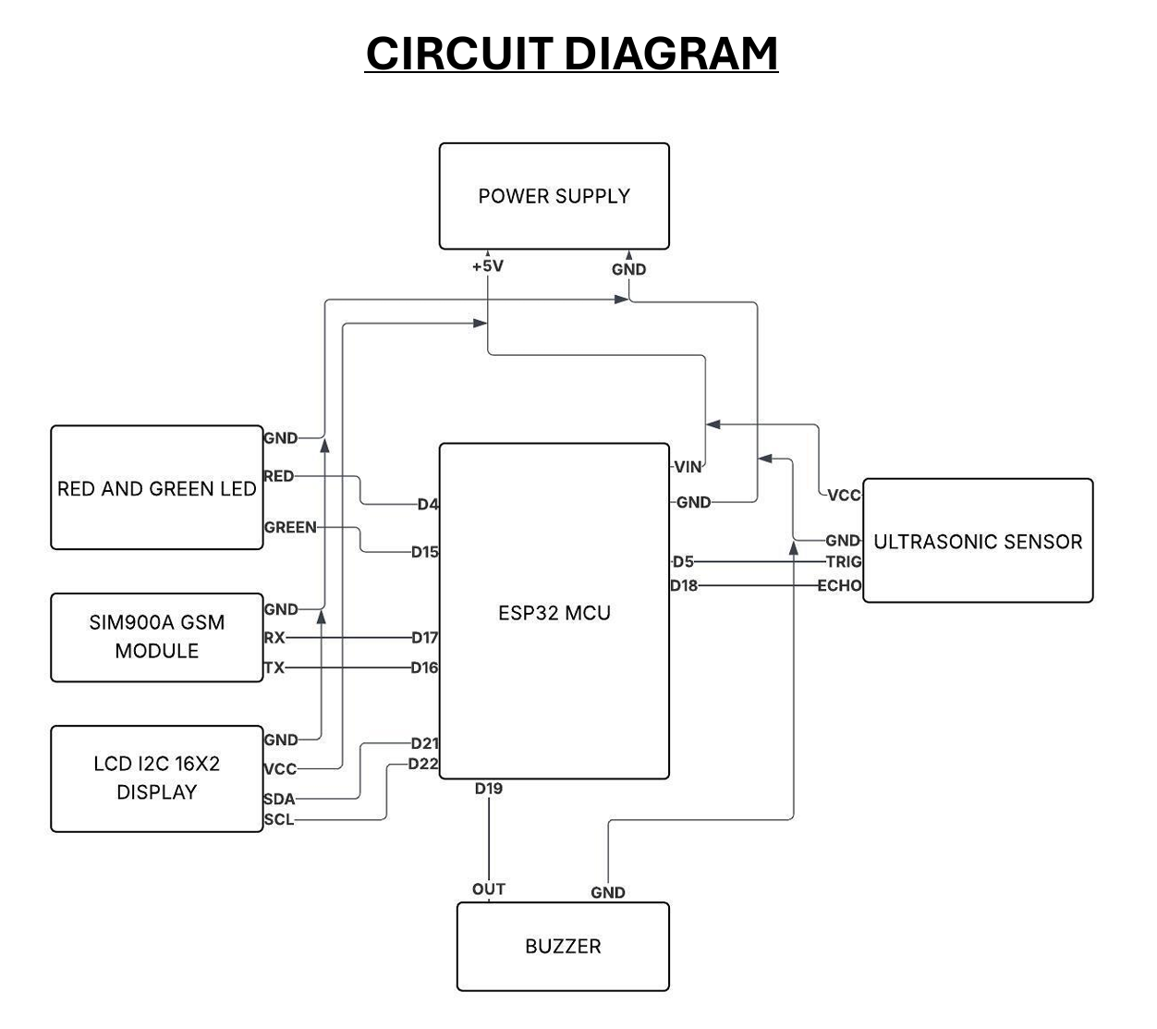
Figure 2
Data Ingestion:
Time series databases such as Influx DB analyse the data in a time series context within predefined intervals to validate whether sensors are actually failing. Today, we’ll use automated techniques, like Isolation Forests and Z-scores, to learn about outliers.
HEC-RAS Hydrodynamic Simulations:
• 2D Mesh Generation: They convert Digital Elevation Models into a mesh to carry out simulations of water flow with a resolution on the order of meters, often between 5 and 30.
Automated Scenario Generation Cloud, Offline Processing: We precompute thousands of flood scenarios with different hydrographs so that we can have more accurate predictions even when the systems are not available.
• Model calibration: The model is calibrated on a regular basis by using historical flood observations and Sentinel-1 SAR satellite images to improve the CS.

3.4 Visualization
A dual-interface :
• Mobile App: A Minimal Interface for Local Emergency Responders It can even cache the data to the device so it can work offline It also sends a push notification to the user’s device warning of an incoming flood near their current location by GPS.

3.5 Stack technology
It should be accurate and scalable.
•Hydraulic Model: this model is selected because it is free of cost and used by many institutions.
• GIS Tools: QGIS is used for the model.
•Machine learning incorporation: Some algorithms like Random Forest or XG Boost could be used to increase this threshold crossing alert accuracy.

3.6 Implementation challenges and backup plans (prolonged)
• Uncertain knowledge model: This model is but that this system uses a probabilistic representation of the flood maps producing colored areas with different levels of certitude instead yes or not.
• Connectivity assurance: The device features LoRaWAN so users can enjoy up to 15 km of connection from a gateway.
•Community integration: Alert features, which rely on simple icons and messages in various languages, are available to assist with that.
IV. Timeline 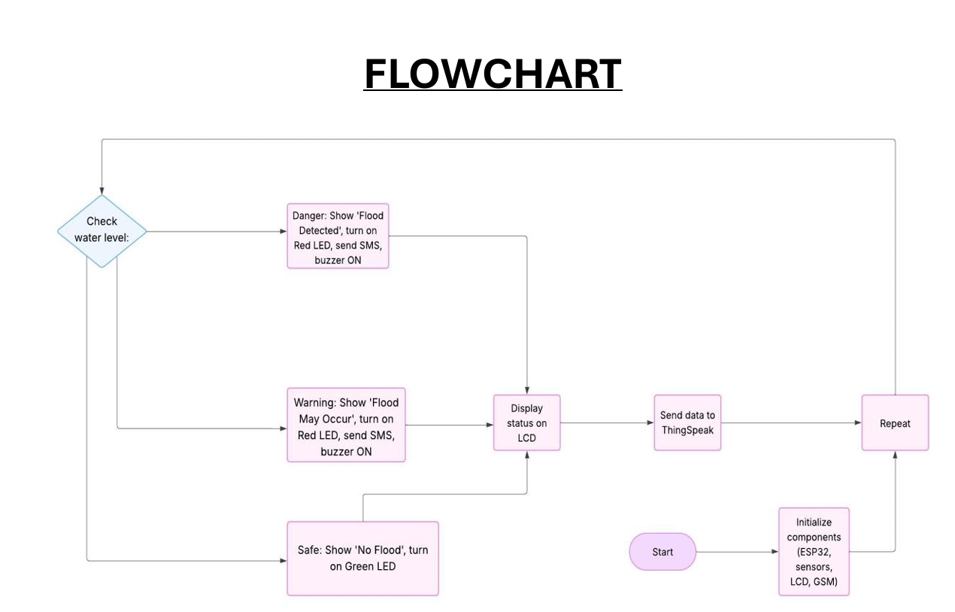
Figure 3
The broader impact of this work is of general relevance in a variety of settings not limited to direct estimation of differential education impact.
With the application of IoT technology and computational hydrology, we hope this project will test such a prototype not only to develop but also to generalize with what it can establish a continuous national integrative flood early warning system.
impactful Broader :
• Mitigates the problem of too many false alarms, so that people can trust when warnings are given.
• Good for the majority of river systems and can be fished all over.
• Ties up with the State Disaster Management Authority’s (SDMA) warning chain
V. Case studies and comparative study
• Assam Floods (2020): Internet of Things for flood prediction to minimize human displacement.
• Kerala Floods (2018): Mapping the flood areas after the event using digital elevation models demonstrated how accurate high-resolution hydrodynamic models can be.
VI. Future Plans
Short term forecasting using recurrent neural networks
• Citizen reports are collected and fed into government dashboards, often through crowd-sourced systems.
• Disaster data is stored in blockchain, i.e. there is no possibility of altering the disaster records and hence it is transparent.
References
K. Mahato, P. Sarma and P. Barman, "An IoT based real-time Flood system," 2024 and IEEE Weather Monitoring Calcutta Conference (CALCON), Kolkata, India, 2024, pp. 1-5, doi: 10.1109/CALCON63337. 2024. 10914313.
[5] B. P. P. Kumar, S. S. Hari Gokul, A. Gow and L. Adarsh, "Remote Monitoring for Water Level of Bridges and Flood Zones," 2025 International Conference on Knowledge Engineering and Communication Systems (ICKECS), Chickballapur, India, 2025, pp. 1-6, doi: 10.1109/ICKECS65700. 2025. 11035864.
S. Sindhuja and V. Sravanthi, "IoT Based Flood Monitoring and Alerting System for Smart Cities," 2024 1st International Conference on Innovative Sustainable Technologies for Energy, Mechatronics, and Smart Systems (ISTEMS), Dehradun, India, 2024, pp. 1-4, doi: 10.1109/ISTEMS60181. 2024. 10560215.
S. Gunanandhini, LM C. M. R. R P K S and N Kl V., "Forecasting and Real Time Flood Monitoring System using IoT," 2024 10th International Conference on Advanced Computing and Communication Systems (ICACCS), Coimbatore, India, 2024, pp. 1228-1233,
doi:10.1109/ICACCS60874.2024.10716883.
[1] P. Chitra, K. Acharjya , V.Ojha , P.Das, A. Faiz and S.BRao, "IOT and Sensor-Based Flood Monitoring and Warning Systems for Disaster Management," 2025 International Conference on Automation a nd Computation (AUTOCOM), Dehradun, India, 2025 pp. 47 1-476,doi:10.1109/AUTOCOM64127.2025 10956605.
[Online]. [J. D. Loong, R. Abdulla, S. K. Selvaperumal and M. E. Rana, "IoT-Based Flood Monitoring System Using Machine Learning Approach," 2023 4th International Conference on Data Analytics for Business and Industry (ICDABI), Bahrain, 2023, pp.A47-53.]doi:10.byte/ICDABI60145/A47-A532010/ICDABI601452023[4]S.Bhattacharyya,Mathew,KVN Nanda(published may 30). 10629349.
V. Banupriya, I. V G, K. S, K. J and Govindan S.R., "Flood and Landslide Prediction and Risk Assessment System using Deep Learning with GSM-based Real Time Alerts," 2025 7th International Conference on Intelligent Sustainable Systems (ICISS), Indian, 2025, pp. 1542-1545 June 2025. 11076263.
A. B, G. Mohith, G. Naveen and K. V. S. Sateesh, "IoT Based Monitoring and Disaster Management System for Dams Using Machine Learning," 2025 International Conference on Inventive Computation Technologies (ICICT), Kirtipur, Nepal, 2025, pp. 1687-1691, doi: 10.1109/ICICT64420. 2025. 11005276.
M. Kumari, A. Bewerwal, A. Kumar, D. Srivastava, G. Saxena and Vikas, "Flood Monitoring and Rescue System Using AI and IoT," 2024 International Conference on Artificial Intelligence and Emerging Technology (Global AI Summit), Greater Noida, India, 2024, pp. 976-981, doi: 10.1109/GlobalAISummit62156.2024.10947954.
[8] R. Raman and S. M. U. Iqbal, "IoT-based Flood Early Warning System for Effective Disaster Management,"2024 International Conference on E-mobility, Power Control and SmartSystems(ICEMPS),Thiruvananthapuram, India, 2024, pp. 1-5. 2024. 10559355K

